**Mini Project - 2**

(2021-2022)

# **Student Result Management System**

**PROJECT REPORT**



**Institute of Engineering &Technology**

## **Submitted To :- Submitted By :-**

Mr. Manoj Varshney Ayush Singh(191500202)

(Assistant Professor)

**Department Of Computer Science Engineering & Applications**



**Department of Computer Engineering and Applications**

**GLA University,17 km.Stone NH#2,Mathura-DelhiRoad,**

**Chaumuha, Mathura – 281406 U.P (India)**

**DECLARATION**

I/we hereby declare that the work which is being presented in the Bachelor of technology. Project **“Student Result Management”**, in partial fulfillment of the requirements for the award of the ***Bachelor of Technology*** in Computer Science and Engineering and submitted to the Department of Computer Engineering and Applications of GLA University, Mathura, is an authentic record of my/our own work carried under the supervision of **Mr. Manoj Varshney, Technical Associate Professor, Dept. of Training and Development, GLA University.**

**Name Of Candidate:**

Ayush Singh

(191500202)



**Department of Computer Engineering and Applications**

**GLA University,17 km.Stone NH#2,Mathura-DelhiRoad,**

**Chaumuha, Mathura – 281406 U.P (India)**

# **Certificate**

This is to certify that the project entitled “Student Result Management System”carried out in Mini Project – I Lab, is a bonafide work of Ayush Singh and is submitted in partial fulfillment of the requirements for the award of the degree Bachelor of Technology (Computer Science & Engineering).

**Signature of Supervisor:**

Mr.Manoj Varshney

(Associate Professor)

(Department of Training and Development)

**Date:**

**ACKNOWLEDGEMENT**

It gives me a great sense of pleasure to present the Final Report of the B.Tech Mini Project(Prak - justBuyUnique) undertaken during B.Tech IIIrd Year. This project in itself is going to be an acknowledgement to the inspiration, drive and technical assistance will be contributed to it by many individuals. I owe Special debt of gratitude to Mr. Manoj Varshney, Associate Professor of Department of CEA, for providing me with an encouraging platform to develop this project , which thus helped me in shaping our abilities towards a constructive goal and for his constant support and guidance to our work. His sincerity, thoroughness and perseverance has been a constant source of inspiration for me.

I want to thank my parents and lord, because without their blessing , perhaps we could do nothing. I am thankful to the various Authors who have contributed material for this project.I wish to thank all my friends, colleagues, students and brother professionals, who have helped me with the critical review of this project including my Friend’s. Their Debugging skills and gratitude appreciated.

**Ayush Singh (191500202)**

**ABSTRACT**

The purpose of Student Result Management System is to automate the existing manual system by the help of computerized equipment and full-fledged computer software, fulfilling their requirements, so that their valuable data/information can be stored for a longer period with easy accessing and manipulation of the same. The required software and hardware are easily available and easy to work with.

Student Result Management System, as described above, can lead to error free, secure, reliable and fast management systems. It can assist the user to concentrate on their other activities rather than concentrating on the record keeping. Thus it will help organizations in better utilization of resources. The organization can maintain computerized records without redundant entries. That means that one need not be distracted by information that is not relevant, while being able to reach the information.

The aim is to automate its existing manual system by the help of computerized equipment and full-fledged computer software, fulfilling their requirements, so that their valuable data/information can be stored for a longer period with easy accessing and manipulation of the same. Basically the project describes how to manage for good performance and better services for the clients.

**CONTENTS**

* Declaration………………………………………………………………..…….(2)
* Certificate……………………………………………………………………….(3)
* Acknowledgement………………………………………………………..……..(4)
* Abstract…………………………………………………………………...……..(5)
* Content………………………………………………………………………….(6)
* List Of Figures…………………………………………………………….…….(8)
* Chapter 1: Introduction ………………………………………………………....(9)
  + 1.1 Context……………………………………..……………………..….(9)
  + 1.2 Motivation………………………..………………………….……….(9)
  + 1.3 Objective…………………………..………………………………....(9)
  + 1.4 Sources…………………………………..…………………………..(10)
* Chapter 2: Software Requirement Analysis…………………………………....(11)
* Chapter 3: Software and System Design ……………………………………...(13)
* Chapter 4: Technology used…………………………………………………...(16)
  + 4.1: Front End technology…………………………………………………..…(16)
  + 4.2: Back End technology……………………………………………….…….(20)
* Chapter 5: Feasibility Study and Implementation ………………………….…(22)
* Chapter 6: User Interface………………………………………………….…..(25)
* Chapter 7: Testing………………………………………………………….…..(31)
* Conclusion……………………………………………………………………..(35)
* References………………………………………………………………...……(36)

**LIST OF FIGURE**

* Figure 1……………………………………………………………….…(14)
* Figure 2……………………………………………………………….…(14)
* Figure 3………………………………………………………….………(15)
* Figure 4……………………………………………………….…………(25)
* Figure 5…………………………………………………………………(26)
* Figure 6………………………………………………………………….(26)
* Figure 7……………………………………………………………..…..(27)
* Figure 8…………………………………………………………………(27)
* Figure 9…………………………………………………………..……..(28)
* Figure 10………………………………………………………………...(28)
* Figure 11………………………………………………………………....(29)
* Figure 12…………………………………………………………………(29)
* Figure 13…………………………………………………………….…..(30)
* Figure 14…………………………………………………………………(30)

**CHAPTER-1**

**INTRODUCTION**

### **1.1 CONTEXT**

This Web Application “Student Result Management System” has been submitted in partial fulfilment of the requirements for the award of the degree of Bachelor of Technology in Computer Science and Engineering at **GLA University**, Mathura supervised by **Mr. Manoj Varshney.** This project has been completed approximately three months and has been executed in modules, meetings have been organized to check the progress of the work and for instruction and guidelines.

### **1.2 MOTIVATION**

This specification document describes the capabilities that will be provided by the software application **STUDENT RESULT MANAGEMENT SYSTEM**. It also states the various constraints by which the system will abide. The intended audience for this document are the development team, testing team and end users of the product.

### **1.3 OBJECTIVE**

The main objective of the Project on Student Result Management System is to manage the details of Result, Student, Progress, Activity, Exam. It manages all the information about Result, Course, Exam, Result. The project is totally built at the administrative end and thus only the administrator is guaranteed access. The purpose of the project is to build an application program to reduce the manual work for managing the Result, Student, Course, Progress. It tracks all the details about the Progress, Activity, Exam.

### **1.4 SOURCES**

The source of our project (including all the project work, documentations and presentations) will be available at the following link.

Git-Hub Link -

<https://github.com/ayushs-bit/StudentResult>

Google Drive Link -

<https://drive.google.com/drive/folders/1kBe5ggS0ghl1IpgWYmA_aME_mRV-ITsr>

**CHAPTER -2**

**SOFTWARE REQUIREMENT ANALYSIS**

## **The proposed system has the following requirements:**

* System needs to store information about the new entry of Result.
* System needs to help the internal staff to keep information about students and find them as per various queries.
* System needs to maintain a quantity record.
* System needs to keep the record of Progress.
* System needs to update and delete the record.
* System also needs a search area.
* It also needs a security system to prevent data

## **HARDWARE AND SOFTWARE REQUIREMENTS**

**Hardware Requirements**

* Hard Disk : 256GB
* RAM : 4GB or higher
* Processor : 1.6 GHz or faster processor

**Software Requirements**

* Operating System : Windows,MAC OS
* UserInterface:HTML,CSS,BOOTSTRAP
* Database : MySQL
* Programming Language : PHP
* Application Software : Visual Studio Code (version 1.61.0)
* Web Browser : Google Chrome, Mozilla Firefox

**CHAPTER - 3**

**Software and System Design**

# **System Design of Result Management System**

In this phase, a logical system is built which fulfills the given requirements. Design phase of software development deals with transforming the client's requirements into a logically working system. Normally, design is performed in the following in the following two steps:

## **1. Primary Design Phase:**

In this phase, the system is designed at block level. The blocks are created on the basis of analysis done in the problem identification phase. Different blocks are created for different functions; emphasis is put on minimizing the information flow between blocks. Thus, all activities which require more interaction are kept in one block.

## **2. Secondary Design Phase:**

In the secondary phase the detailed design of every block is performed.

# **User Interface Design**

User Interface Design is concerned with the dialogue between a user and the computer. It is concerned with everything from starting the system or logging into the system to the eventual presentation of desired inputs and outputs. The overall flow of screens and messages is called a dialogue.

**Context Diagram**

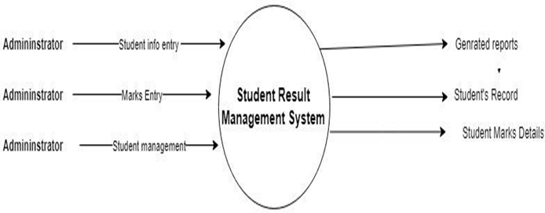

**Figure 1**

**Student case Diagram**

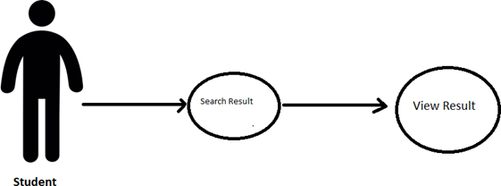

**Figure 2**

**Admin Case Diagram**

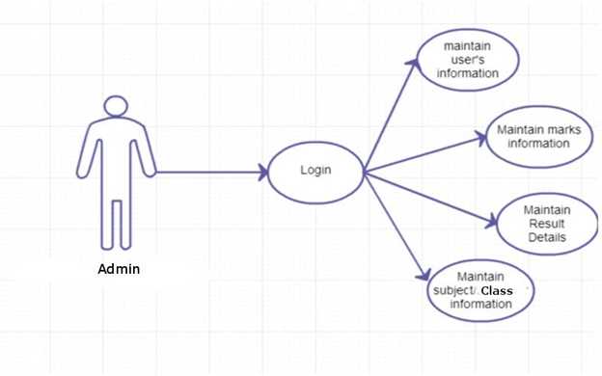

**Figure 3**

**CHAPTER-4**

## **TECHNOLOGY USED**

**4.1 Front End Technology**

**HTML**

The hypertext markup language (HTML) is a simple markup language. Used to create hypertext documents that are portable from one platform to another HTML documents are SGML (Standard generalized markup language) documents with generic semantics that are appropriate for representing information from a wide range of applications. This specification defines HTML version 3 2. HTML 3.2

aims to capture recommended practice as of early ’96 and as such a replacement for HTML 2.0 (RFC 1866).

A set of instructions embedded in a document is called markup language. These instructions describe what the document text means and how it should look like in a display. Hypertext MarkUp language (HTML) is the language used to encode World Wide Web documents.

###### **WHY TO USE HTML?**

Website is a collection of pages, publications, and documents that reside on web server. While these pages are publications and a document as a formatted in a single format, you should use HTML for the home page and all primary pages in the site. This will enable millions of web users to easily access and to take advantage of your website.HTML is considered first for formatting any new material you plan to publish on the web. HTML documents are platform independent, meaning that they don’t conform to any standard.

**CSS**

**Cascading Style Sheets** (**CSS**) is a [style sheet language](https://en.wikipedia.org/wiki/Style_sheet_language) used for describing the [presentation](https://en.wikipedia.org/wiki/Presentation_semantics) of a document written in a [markup language](https://en.wikipedia.org/wiki/Markup_language) such as [HTML](https://en.wikipedia.org/wiki/HTML). CSS is a cornerstone technology of the [World Wide Web](https://en.wikipedia.org/wiki/World_Wide_Web), alongside HTML and [JavaScript](https://en.wikipedia.org/wiki/JavaScript).CSS is designed to enable the separation of presentation and content, including [layout](https://en.wikipedia.org/wiki/Page_layout), [colors](https://en.wikipedia.org/wiki/Color), and [fonts](https://en.wikipedia.org/wiki/Typeface). This separation can improve content [accessibility](https://en.wikipedia.org/wiki/Accessibility); provide more flexibility and control in the specification of presentation characteristics; enable multiple [web pages](https://en.wikipedia.org/wiki/Web_page) to share formatting by specifying the relevant CSS in a separate .css file, which reduces complexity and repetition in the structural content; and enable the .css file to be [cached](https://en.wikipedia.org/wiki/Cache_(computing)) to improve the page load speed between the pages that share the file and its formatting. Separation of formatting and content also makes it possible to present the same markup page in different styles for different rendering methods, such as on-screen, in print, by voice (via speech-based browser or [screen reader](https://en.wikipedia.org/wiki/Screen_reader)), and on [Braille-based](https://en.wikipedia.org/wiki/Braille_display) tactile devices. CSS also has rules for alternate formatting if the content is accessed on a [mobile device](https://en.wikipedia.org/wiki/Mobile_device).The name *cascading* comes from the specified priority scheme to determine which style rule applies if more than one rule matches a particular element. This cascading priority scheme is predictable.Separation of formatting and content also makes it possible to present the same markup page in different styles for different rendering methods, such as on-screen, in print, by voice (via speech-based browser or screen reader), and on Braille-based tactile devices. CSS also has rules for alternate formatting if the content is accessed on a mobile device. This cascading priority scheme is predictable.CSS has a simple [syntax](https://en.wikipedia.org/wiki/Syntax) and uses a number of English keywords to specify the names of various style properties. A style sheet consists of a list of *rules*. Each rule or rule-set consists of one or more [*selectors*](https://en.wikipedia.org/wiki/CSS#Selector), and a [*declaration block*](https://en.wikipedia.org/wiki/CSS#Declaration_block). A declaration block consists of a list of *declarations* in braces. Each declaration itself consists of a *property*, a colon (:), and a *value*. If there are multiple declarations in a block, a semi-colon (;) must be inserted to separate each declaration.

**JAVASCRIPT**

**JavaScript** is a [high-level](https://simple.wikipedia.org/wiki/High-level_programming_language) [programming language](https://simple.wikipedia.org/wiki/Programming_language) that follows the ECMAScript standard. It was originally designed as a [scripting language](https://simple.wikipedia.org/wiki/Scripting_language) for websites but became widely adopted as a [general-purpose programming language](https://simple.wikipedia.org/wiki/General-purpose_programming_language), and is currently the most popular programming language in use. JavaScript is usually found running in a web browser as interactive or automated content, ranging from popup messages and live [clocks](https://simple.wikipedia.org/wiki/Clock) to large [web applications](https://simple.wikipedia.org/wiki/Web_application). JavaScript is also commonly used in [server-side](https://simple.wikipedia.org/wiki/Server) programming through platforms like [Node.js](https://simple.wikipedia.org/wiki/Node.js), or "embedded" in non-JavaScript applications where the base programming language lacks the high-level functionality that JavaScript offers.JavaScript is typically inserted into [HTML](https://simple.wikipedia.org/wiki/HTML) when used on the web, either directly in the [file](https://simple.wikipedia.org/wiki/File) in an HTML tag, or [linked](https://simple.wikipedia.org/wiki/Link) to a separate file containing the script. JavaScript, as a full featured scripting language, can be used to provide functionality to a website.

A JavaScript [program](https://simple.wikipedia.org/wiki/Computer_program) is made of a collection of instructions called "statements". A [semicolon](https://simple.wikipedia.org/wiki/Semicolon) marks the end of a statement, and allows multiple statements to be placed on the same line. However, it is typical to write each statement on its own line to keep a program file readable.Variables can be defined in several ways. Variables are defined using the var keyword. Variables can be defined using const for constant variables and let for local variables. The value of constant variables cannot be re-declared or reassigned. Variables assigned using const or let are contained within blocks, while variables assigned using var are contained within functions.

# **BOOTSTRAP**

**Bootstrap** is a [free and open-source](https://en.wikipedia.org/wiki/Free_and_open-source) [CSS framework](https://en.wikipedia.org/wiki/CSS_framework) directed at responsive, [mobile-first](https://en.wikipedia.org/wiki/Responsive_web_design#Mobile_first,_unobtrusive_JavaScript,_and_progressive_enhancement) [front-end web development](https://en.wikipedia.org/wiki/Front-end_web_development). It contains [CSS](https://en.wikipedia.org/wiki/CSS)- and (optionally) [JavaScript](https://en.wikipedia.org/wiki/JavaScript)-based design templates for [typography](https://en.wikipedia.org/wiki/Web_design#Typography), [forms](https://en.wikipedia.org/wiki/Form_(HTML)), [buttons](https://en.wikipedia.org/wiki/Button_(computing)#HTML), [navigation](https://en.wikipedia.org/wiki/Web_navigation#Local_website_navigation), and other interface components.

Bootstrap is an HTML, CSS & JS Library that focuses on simplifying the development of informative web pages (as opposed to [web apps](https://en.wikipedia.org/wiki/Web_Apps)). The primary purpose of adding it to a web project is to apply Bootstrap's choices of color, size, font and layout to that project. As such, the primary factor is whether the developers in charge find those choices to their liking. Once added to a project, Bootstrap provides basic style definitions for all [HTML elements](https://en.wikipedia.org/wiki/HTML_element). The result is a uniform appearance for prose, tables and form elements across [web browsers](https://en.wikipedia.org/wiki/Web_browser). In addition, developers can take advantage of CSS classes defined in Bootstrap to further customize the appearance of their contents. For example, Bootstrap has provisioned for light- and dark-colored tables, page headings, more prominent [pull quotes](https://en.wikipedia.org/wiki/Pull_quote), and text with a highlight.

Bootstrap also comes with several JavaScript components in the form of [jQuery](https://en.wikipedia.org/wiki/JQuery) plugins. They provide additional user interface elements such as [dialog boxes](https://en.wikipedia.org/wiki/Dialog_box), [tooltips](https://en.wikipedia.org/wiki/Tooltip), and carousels. Each Bootstrap component consists of an HTML structure, CSS declarations, and in some cases accompanying JavaScript code. They also extend the functionality of some existing interface elements, including for example an auto-complete function for input fields.

**4.2 Back End Technology**

###### **MYSQL**

There are a large number of database management systems currently available, some commercial and some free.

Some of them : Oracle, Microsoft Access, Mysql and PostgreSQL.

These database systems are powerful, feature-rich software, capable of organizing and searching millions of records at very high speeds.

Understanding Databases, Records, and Primary Keys Every Database is composed of one or more tables.These Tables, which structure data into rows and columns, Impose organization on the data.The records in a table(below) are not arranged in any particular order.

**SQL, statements fall into one of three categories.(Types of SQL)**

**Data Definition Language(DDL) :** DDL Consists of statements that define the structure and relationships of a database and its table.

These Statements are used to Create, drop and modify databases and tables. Data Manipulation Language(DML) : DML statements are related to altering and extracting data from a database.These statements are used to add records to, update records in, and delete records from, a database; perform queries; retrieve table records matching one or more user specified criteria; and join tables together using their common fields.

**Data Control Language(DCL) :** DCL statements are sued to define access levels and security privileges for a database.You would use these statements to grant or deny user privileges; assign roles; change passwords; view permissions; and create rulesets to protect access to data.The Syntax of SQL is quite intuitive. every SQL statement begins with an “action word”, like DELETE, INSERT,ALTER etc.

## **PHP**

PHP : Hypertext Preprocessor is a [scripting language](https://simple.wikipedia.org/wiki/Scripting_language) that helps people make web pages more interactive by allowing them to do more intelligent, complex things. PHP code is run on the web server.website with no programming cannot do this without other complex things.

Standard PHP [file extensions](https://simple.wikipedia.org/wiki/File_extension) are: .php .php3 or .phtml, but a web server can be set up to use any extension.The PHP code is enclosed in special [start and end processing instructions <?php and ?>](https://www.php.net/manual/en/language.basic-syntax.phpmode.php) that allows you to jump into and out of PHP mode. What distinguishes PHP from something like client-side JavaScript is that the code is executed on the server, generating HTML which is then sent to the client. The client would receive the results of running that script, but would not know what the underlying code was. You can even configure your web server to process all your HTML files with PHP, and then there's really no way that users can tell what you have up your sleeve. PHP defines a large array of functions in the core language and many are also available in various extensions; these functions are well documented in the online [PHP documentation](https://www.php.net/docs.php).

PHP is a general-purpose scripting language that is especially suited to [server-side](https://en.wikipedia.org/wiki/Server-side_scripting) [web development](https://en.wikipedia.org/wiki/Web_development), in which case PHP generally runs on a [web server](https://en.wikipedia.org/wiki/Web_server). Any PHP code in a requested file is [executed](https://en.wikipedia.org/wiki/Execution_(computing)) by the PHP runtime, usually to create [dynamic web page](https://en.wikipedia.org/wiki/Dynamic_web_page) content or dynamic images used on websites or elsewhere. Originally designed to create dynamic [web pages](https://en.wikipedia.org/wiki/Web_page), PHP now focuses mainly on [server-side scripting](https://en.wikipedia.org/wiki/Server-side_scripting), and it is similar to other server-side scripting languages that provide dynamic content from a web server to a [client](https://en.wikipedia.org/wiki/Client_(computing)).

**Chapter-5**

**FEASIBILITY STUDY AND IMPLEMENTATION**

Feasibility study is conducted once the problem is clearly understood. Feasibility study is a high level capsule version of the entire system analysis and design process. The objective is to determine quickly at a minimum expense how to solve a problem. The purpose of feasibility is not to solve the problem but to determine if the problem is worth solving.The system has been tested for feasibility in the following points.

1. Technical Feasibility

2. Economical Feasibility

3. Operational Feasibility.

**1. Technical Feasibility**

The project entitled "Student Result Management System '' is technically feasible because of the below mentioned feature. The project was developed in PHP with Graphical User Interface.

It provides a high level of reliability, availability and compatibility. All these make PHP an appropriate language for this project. Thus the existing software PHP is a powerful language.

**2. Economical Feasibility**

The computerized system will help in automating the selection leading to the profits and details of the organization. With this software, the machine and manpower utilization are expected to go up by 80-90% approximately. The costs incurred of not creating the system are set to be great, because precious time can be wanted by manually.

**3. Operational Feasibility**

In this project, the management will know the details of each project where he may be presented and the data will be maintained as decentralized and if any inquiries for that particular contract can be known as per their requirements and necessaries.

**Implementation:**

Implementation is the stage where the theoretical design is turned into a working system. The most crucial stage in achieving a new successful system and in giving confidence on the new system for the users that it will work efficiently and effectively.

The system can be implemented only after thorough testing is done and if it is found to work according to the specification.It involves careful planning, investigation of the current system and its constraints on implementation, design of methods to achieve the change over and an evaluation of change over methods apart from planning. Two major tasks of preparing the implementation are education and training of the users and testing of the system.The more complex the system being implemented, the more involved will be the systems analysis and design effort required just for implementation.The implementation phase comprises several activities. The required hardware

and software acquisition is carried out. The system may require some software to be developed. For this, programs are written and tested. The user then changes over to his new fully tested system and the old system is discontinued.

**CHAPTER 6**

**USER INTERFACE**

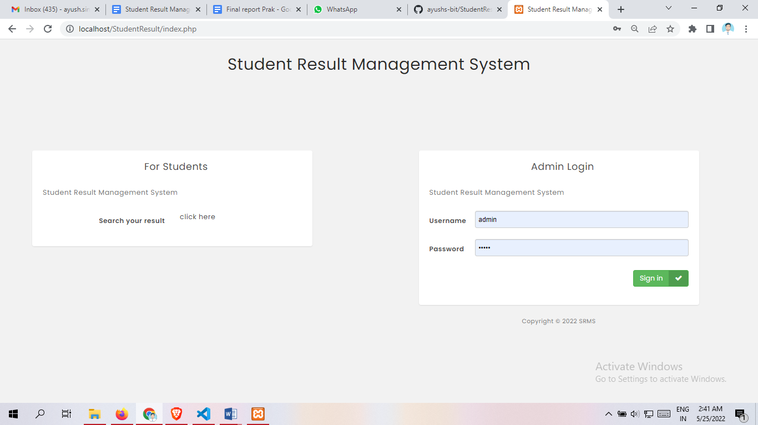

**Figure 4: Homepage**

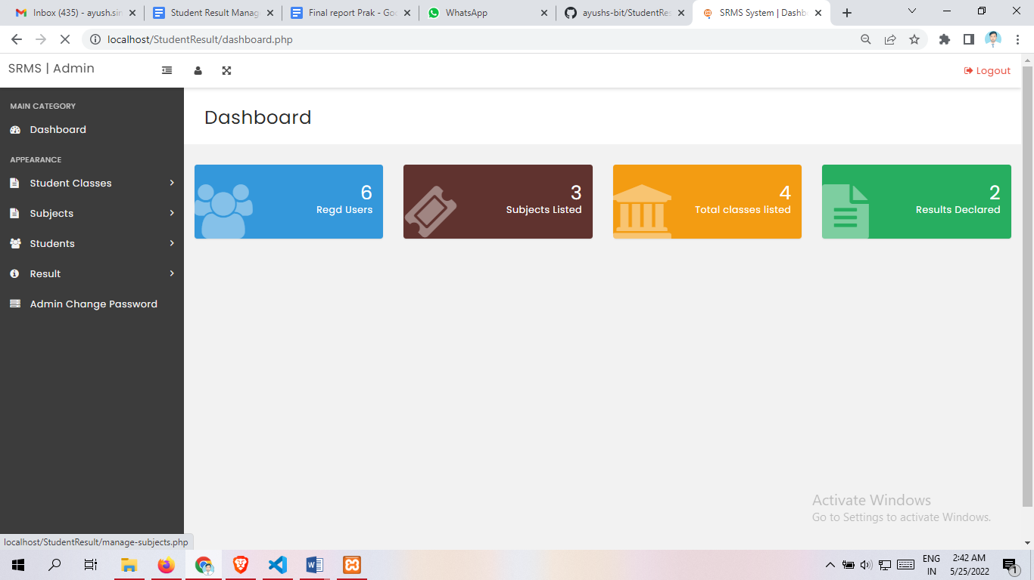

**Figure 5: Dashboard Page**

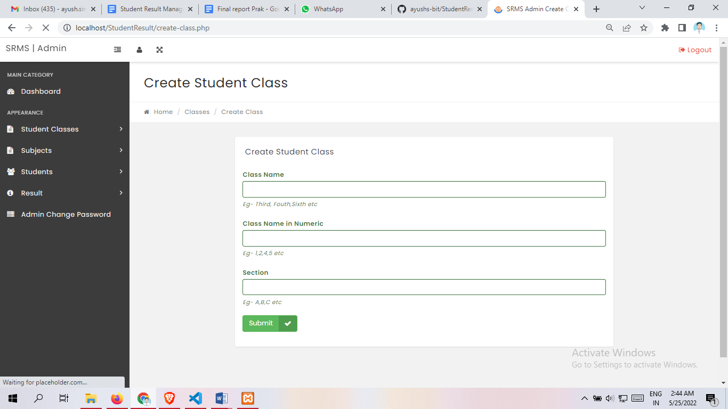

**Figure 6: Create student class**

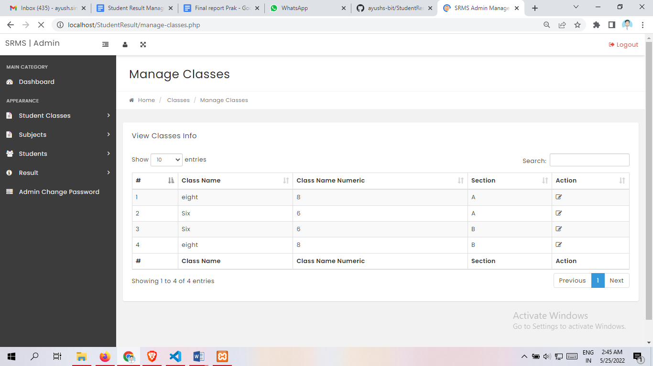

**Figure 7: Manage class**

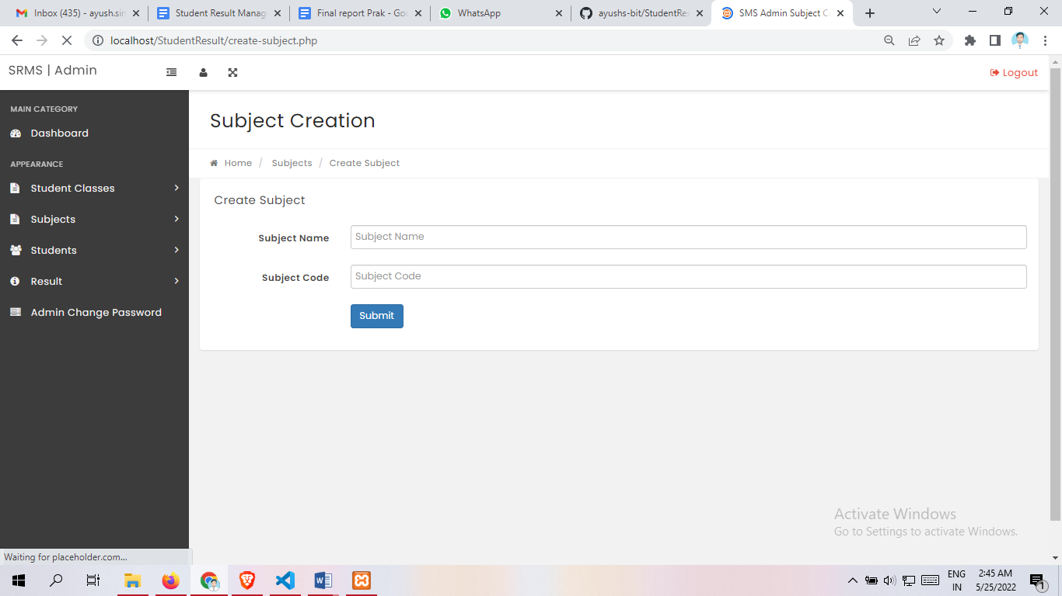

**Figure 8: Subject Creation**

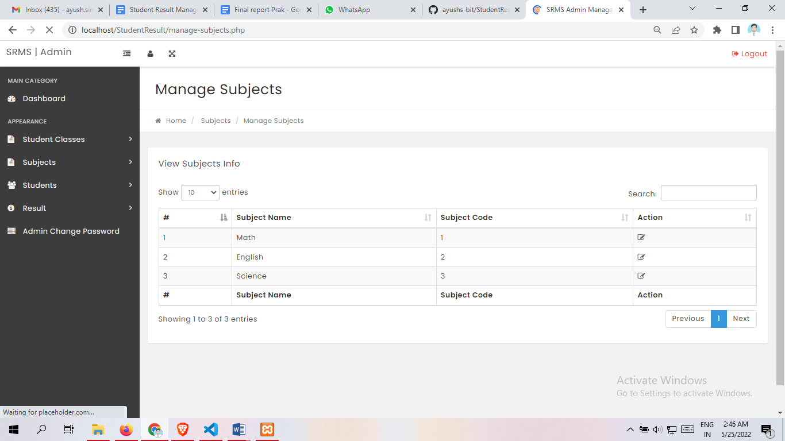

**Figure 9: Manage Subject**

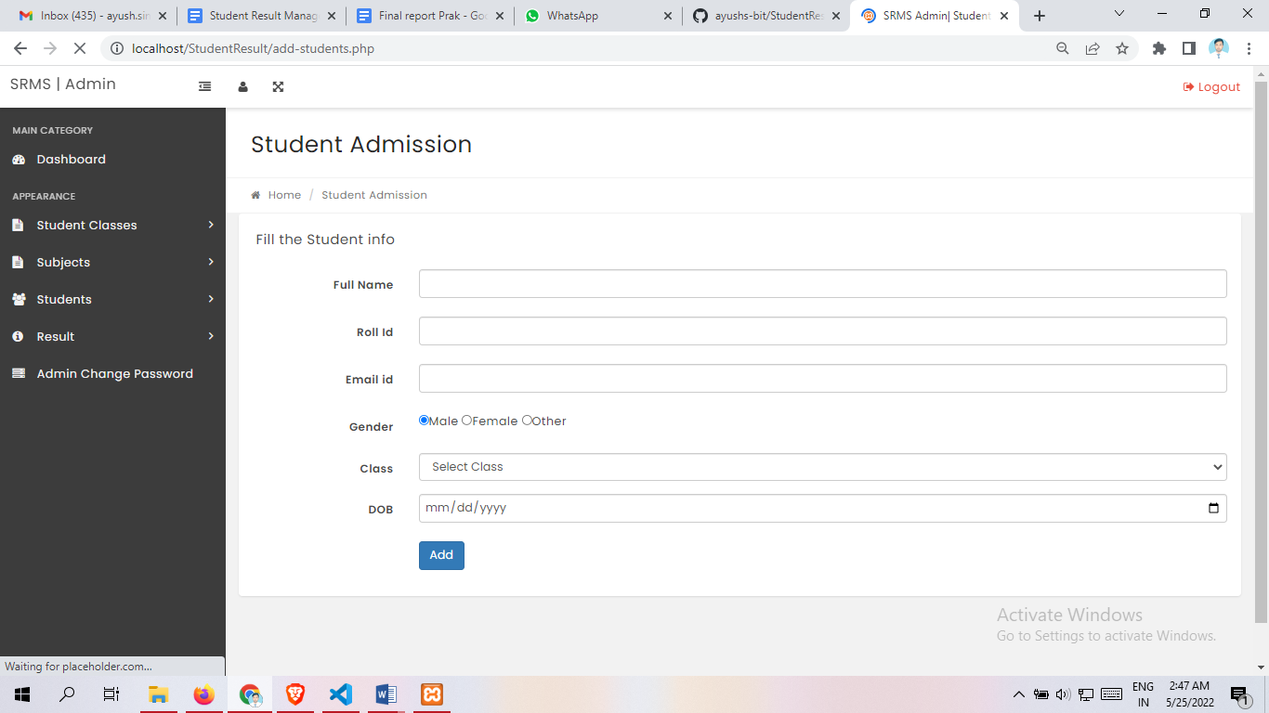

**Figure 10: Student Admission**

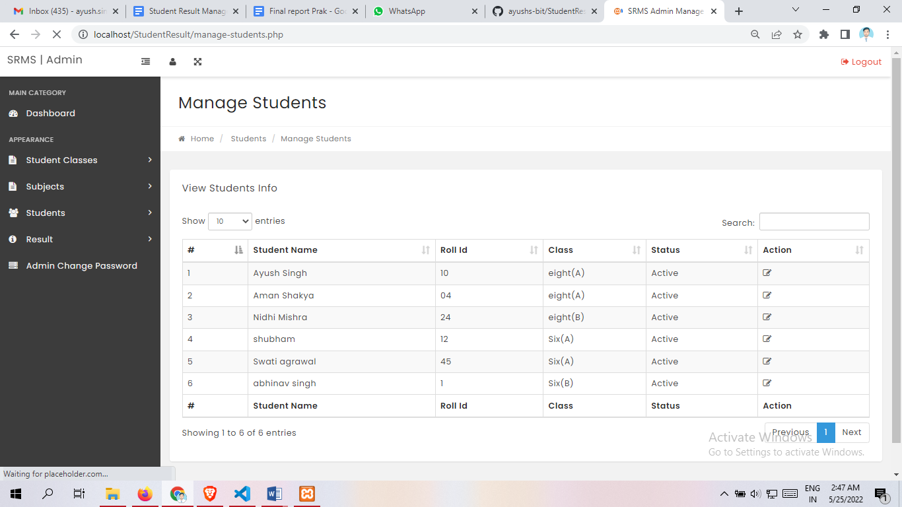

**Figure 11: Manage student**

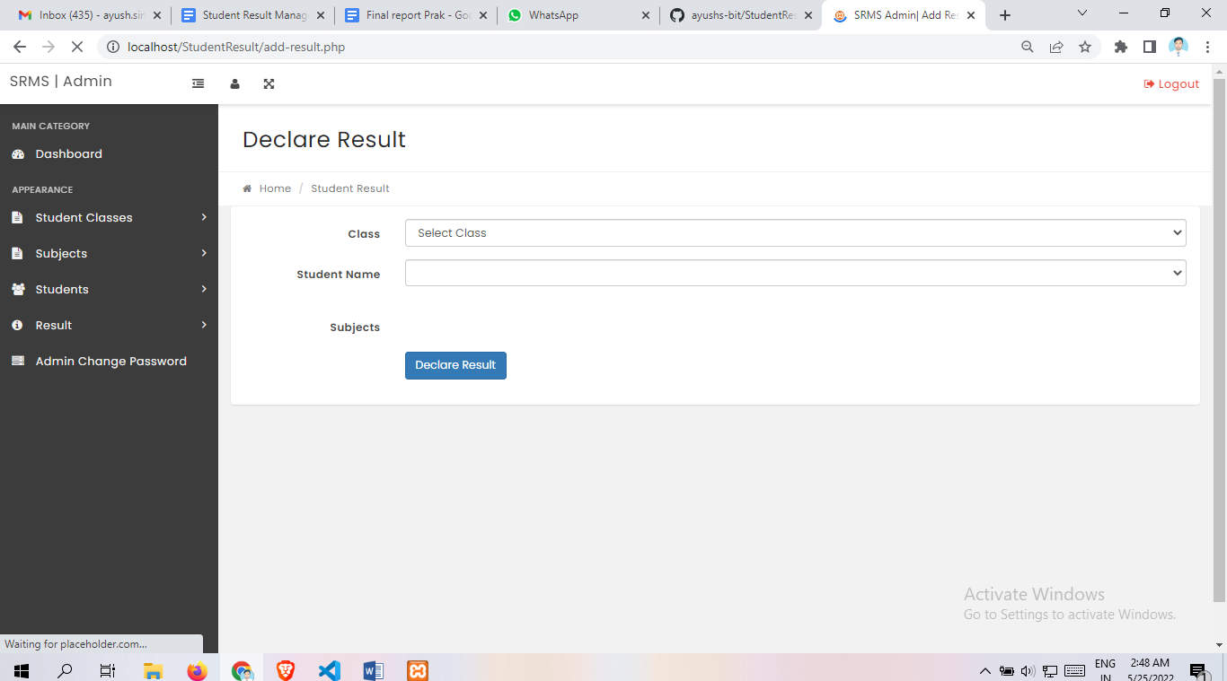

**Figure 12: Declare result**

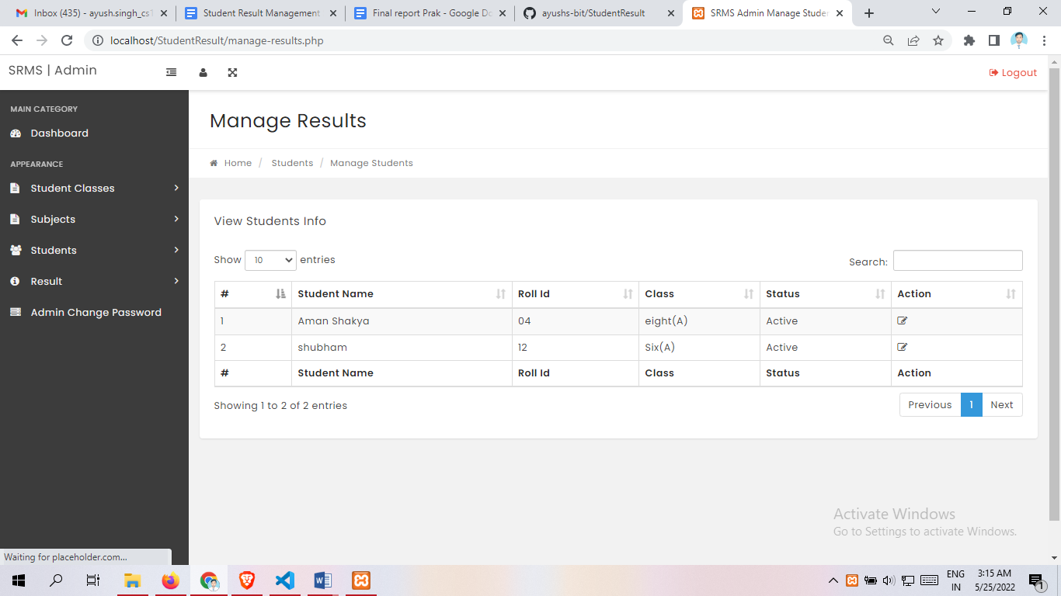

**Figure 13: Manage Results**

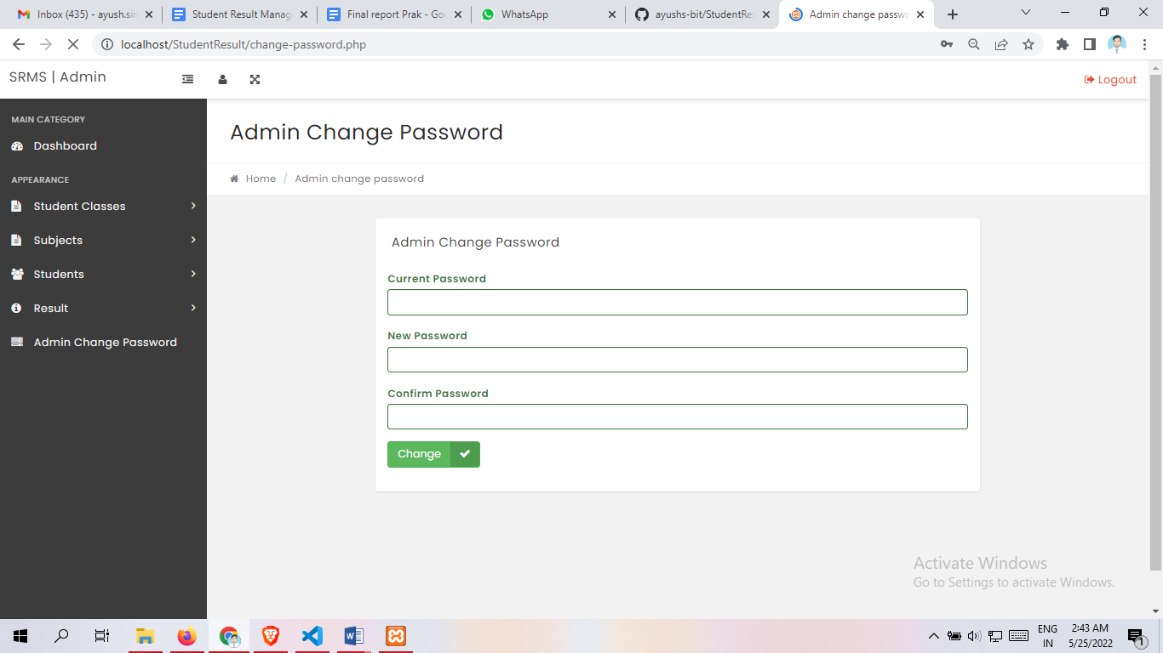

**Figure 14: Admin Change Password**

**CHAPTER - 7**

**TESTING**

Testing is a process of executing a program with the intent of finding an error. Testing is a crucial element of software quality assurance and presents ultimate review of specification, design and coding.

System Testing is an important phase. Testing represents an interesting anomaly for the software. Thus a series of testing are performed for the proposed system before the system is ready for user acceptance testing.A good test case is one that has a high probability of finding an undiscovered error. A successful test is one that uncovers an undiscovered error.

**Testing Objectives:**

1. Testing is a process of executing a program with the intent of finding an error

2. A good test case is one that has a probability of finding an as yet undiscovered error

3. A successful test is one that uncovers an undiscovered error

**Testing Principles:**

* All tests should be traceable to end user requirements
* Tests should be planned long before testing begins
* Testing should begin on a small scale and progress towards testing in large
* Exhaustive testing is not possible
* To be most effective testing should be conducted by a independent third party

**Unit Testing**

It focuses on smallest unit of software design. In this we test an individual unit or groups of inter related units. It is often done by programmer by using sample input and observing its corresponding outputs. In this testing technique we are primarily focuses on

* Loop methods and function is working fine or not. Misunderstood or incorrect Arithmetic precedence
* Incorrect Initialization

Unit Testing of the :

| Test cases | Description | Expected Outcome | Result |
| --- | --- | --- | --- |
| 1 | Start Page – Hompepage | Should display Homepage with admin login and student result search panel | Pass |
| 2 | Dashboard Screen | Should display dashboard screen with navigation panel on left. | Pass |

| 3 | Create student class page | Should display the panel for student admission |  |
| --- | --- | --- | --- |
| 4 | Manage student Page | Should display the student admitted or created | Pass |
| 5 | Create Subject Page | Should display the panel for subject creation | Pass |
| 6 | Manage Subject Page | Should show the subject created | Pass |

| 7 | | Student Admission Page | Should display the information that you have entered | Pass |
| --- | --- | --- | --- | --- |
| 8 | | Manage Student Page | View Home Page | Pass |
| 9 | | Declare Result | Should show the result declared | Pass |
| 10 | | Manage Result | Show the declared result and  You can edit those result | Pass |
| 11 |  | Admin Change Password | Password can be changed | Pass |
| 12 |  | Main Category Side Panel | Should display all the category of management system | Pass |
| 13 |  | Top Navigation bar | Should display the profile,full screen and logout button | Pass |
| 14 |  | Logout | Sign out you from the website | Pass |

**User Testing**

User testing is the process through which the interface and functions of a website, app, product, or service are tested by real users who perform specific tasks in realistic conditions. The purpose of this process is to evaluate the usability of that website or app and to decide whether the product is ready to be launched for real users.

This website was tested by my friends who are using different mobile operating systems (and having different window versions) also tested on different devices to check its performance and it seems to be working fine and users of this app are satisfied with the facilities and performance of the app and like the way how the website is working.

**System testing**

System testing tests the integration of each module in the system. It also tests to find discrepancies between the system and its original objective, current specification and system documentation. The primary concern is the compatibility of individual modules. Entire system is working properly or not will be tested here, and specified path ODBC connection will correct or not, and giving output or not are tested here these verifications and validations are done by giving input values to the system and by comparing with expected output. Top-down testing implemented here.

**Compatibility Testing**

This application was tested and used on different devices like windows 10,window11, macOS. The website worked fine and is stable. The website worked fine in portrait mode and there isn't any problem with compatibility.

**CONCLUSION**

The package was designed in such a way that future modifications can be done easily. The following conclusions can be deduced from the development of the project.

* Automation of the entire system improves the efficiency
* It provides a friendly graphical user interface which proves to be better when compared to the existing system.
* It gives appropriate access to the authorized users depending on their permissions.
* It effectively overcomes the delay in communications.
* Updating information becomes so easy.
* System security, data security and reliability are the striking features.
* The System has adequate scope for modification in future if it is necessary.

**Reference**

**Reference from W3School:**

* + [**https://www.w3schools.com**](https://www.w3schools.com/)

**Reference from beta-labs:**

* + [**https://www.youtube.com/c/BETALABS_by_Pankaj_Kapoor/**](https://www.youtube.com/c/BETALABS_by_Pankaj_Kapoor/videos)

**Reference from YouTube**

* + [**https://www.youtube.com/watch?v=XHQ3JLg3UsE&t=159s**](https://www.youtube.com/watch?v=XHQ3JLg3UsE&t=159s)

**Geeks Of Geeks:**

* + [**https://www.geeksforgeeks.org/**](https://www.geeksforgeeks.org/)

**Reference from BOOTSTRAP:**

* + [**https://getbootstrap.com/**](https://getbootstrap.com/)

**Reference from Udemy:**

* + [**https://www.udemy.com/**](https://www.udemy.com/)